**NAAN MUDHALVAN-IBM DATA ANALYTICS WITH COGNOS**

**PROJECT PHASE 5**

**Project Documentation and Submission**

**PROJECT TITLE:AIR QUALITY INDEX ANALYSIS**

**TEAM MEMBERS:**

* GokulRaj S - 2021115038
* Hariharan I S - 2021115039
* Gokul V - 2021115037
* Harshith A N - 2021115040
* Gopi R - 2021115315

**Introduction**

*Air quality is an issue of increasing global concern, impacting public health, climate change, and the overall quality of life. The Air Quality Index (AQI) serves as a vital environmental indicator, offering a comprehensive assessment of air quality by considering various pollutants and meteorological factors. Our project, a culmination of thorough data analysis and advanced data visualization, seeks to unravel the complexities of air quality, empowering us to make informed decisions and fostering a deeper understanding of the air we breathe.*

*Over the course of several phases, we've collected, pre-processed, and analyzed a wealth of air quality data. Our journey has taken us through the realms of exploratory data analysis (EDA), statistical analysis, and advanced data visualization, where we've unearthed hidden patterns, temporal trends, and spatial variations in air quality. These findings extend their reach into diverse domains, from environmental policy to public health and urban planning.*

*In Phase 5, we embark on a visually immersive exploration of our data, leveraging advanced visualization techniques that breathe life into our analysis. Our project stands as a testament to the power of data-driven insights, bridging the gap between complex data and informed decisions. As we conclude this endeavor, we present not just our findings but also a blueprint for future projects, with a commitment to fostering a cleaner and healthier environment.*

**Advanced Data Visualization**

*In this phase, we harness the strength of advanced data visualization to illuminate the intricacies of our AQI data. Through interactive dashboards, time-series visualizations, geospatial heatmaps, and 3D plots, we offer an enriched perspective on air quality. These advanced visualizations enable dynamic exploration, transforming raw data into meaningful insights.*

**Interactive Dashboards:**

*Our interactive dashboards enable dynamic exploration of air quality data. Users can select specific regions, pollutants, and time frames, gaining an in-depth understanding of AQI fluctuations. This level of interactivity facilitates on-the-fly analysis and decision-making.*

**Time-Series Visualizations:**

*We unveil temporal trends and seasonality in AQI data through intricate time-series visualizations. These charts capture the ebb and flow of air quality over time, helping us identify patterns and understand the dynamics of air quality throughout the year.*

**Geospatial Heatmaps:**

*Geographic heatmaps transform spatial variations in air quality into vibrant visual displays. By pinpointing regions with the highest and lowest AQI values, we facilitate targeted interventions and resource allocation in areas where they are most needed.*

**3D Visualizations:**

*We leverage 3D visualizations to capture complex interactions between multiple variables, offering an immersive exploration of the relationships between air pollutants, weather conditions, and geographical locations. These visualizations provide a holistic perspective on air quality factors.*

**CODE AND ANALYSIS**

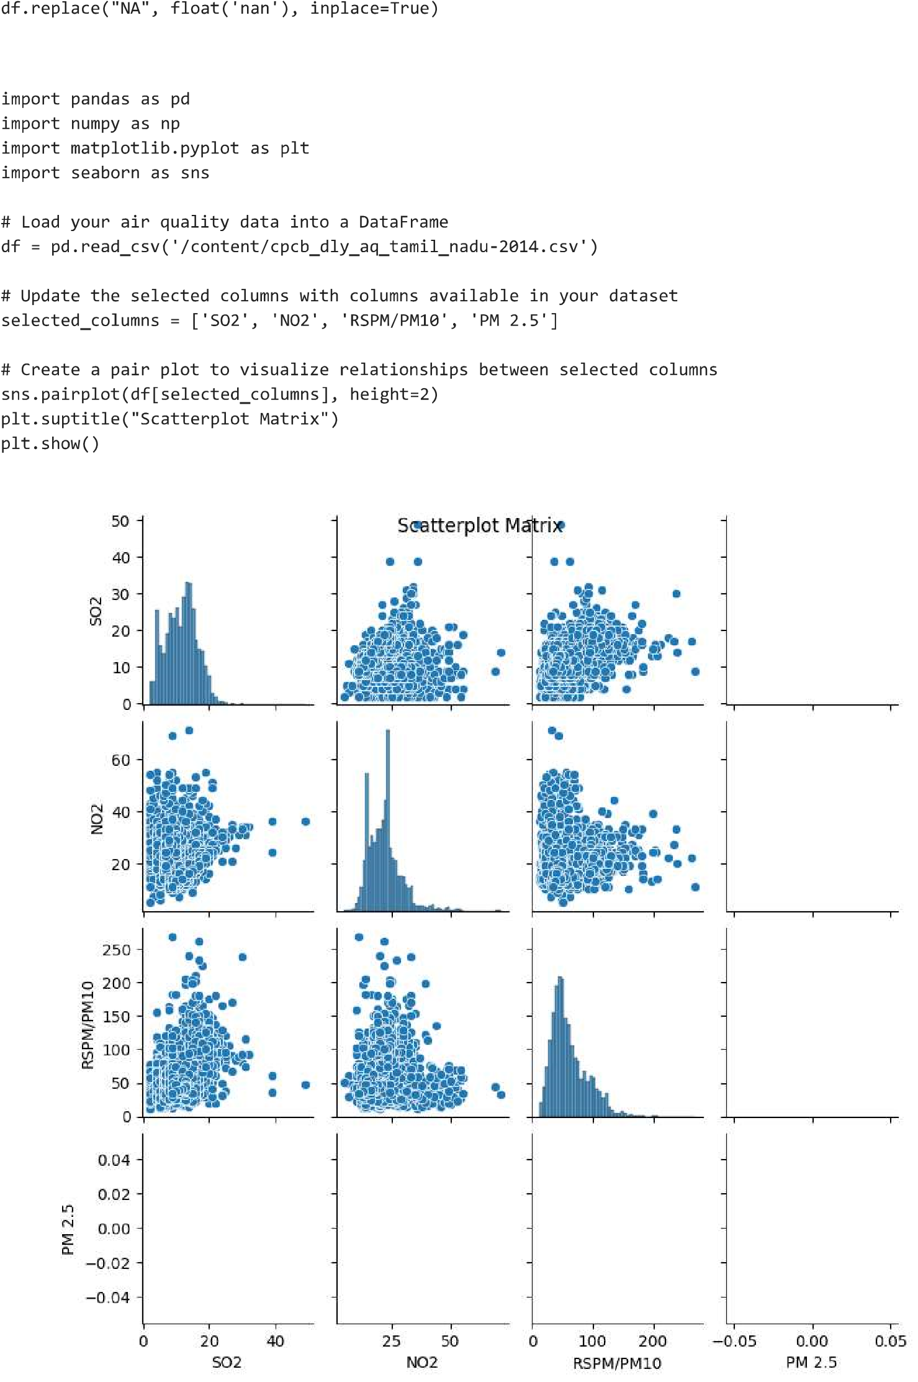

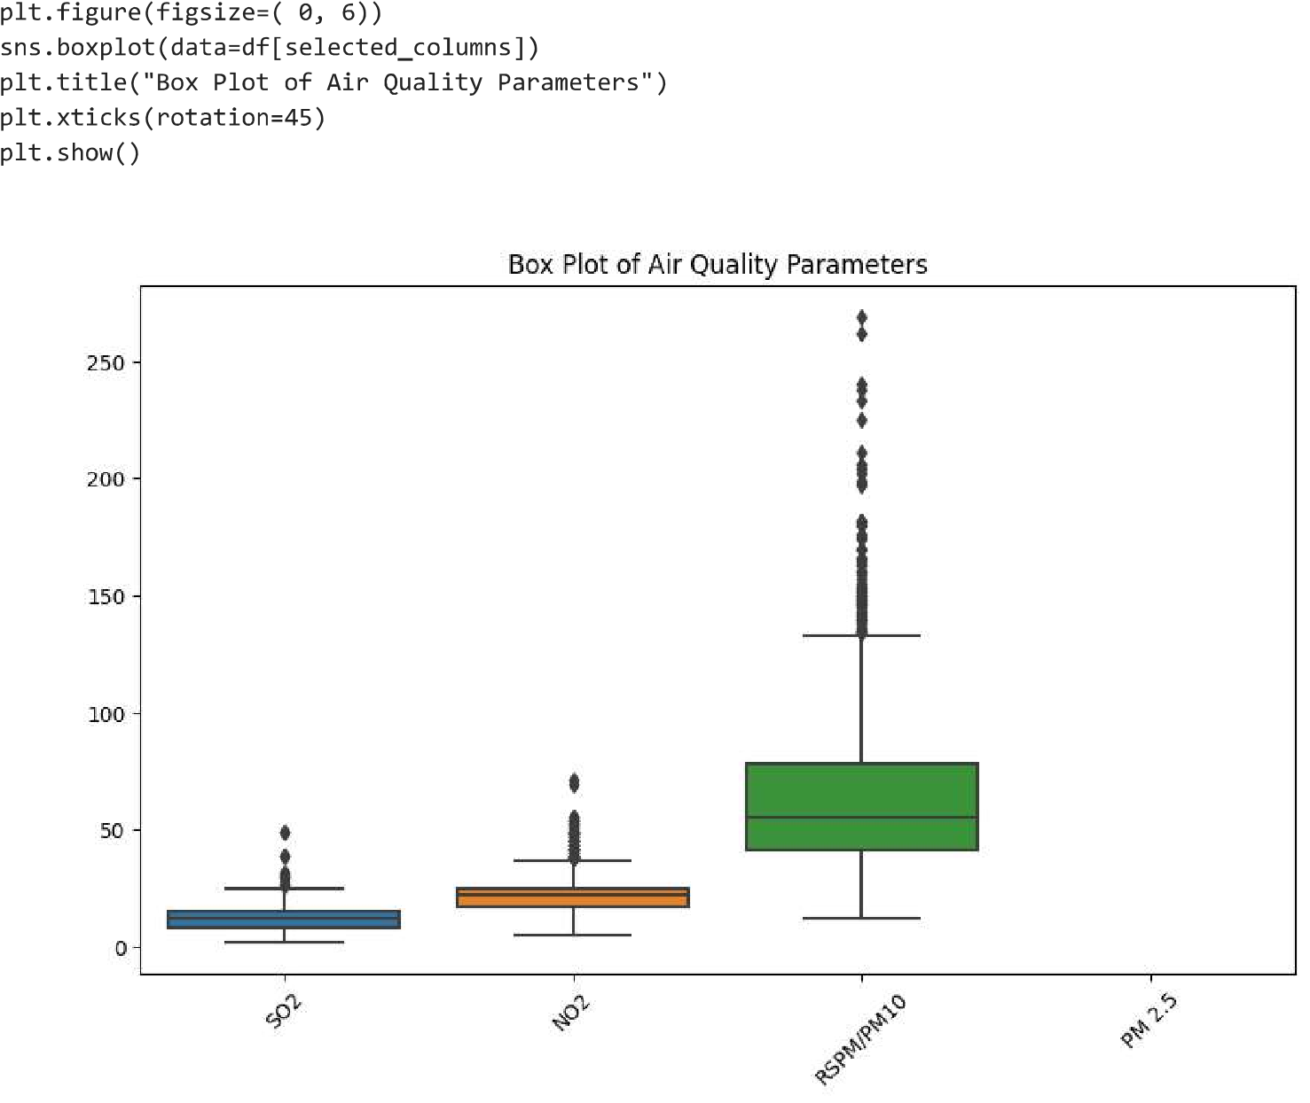

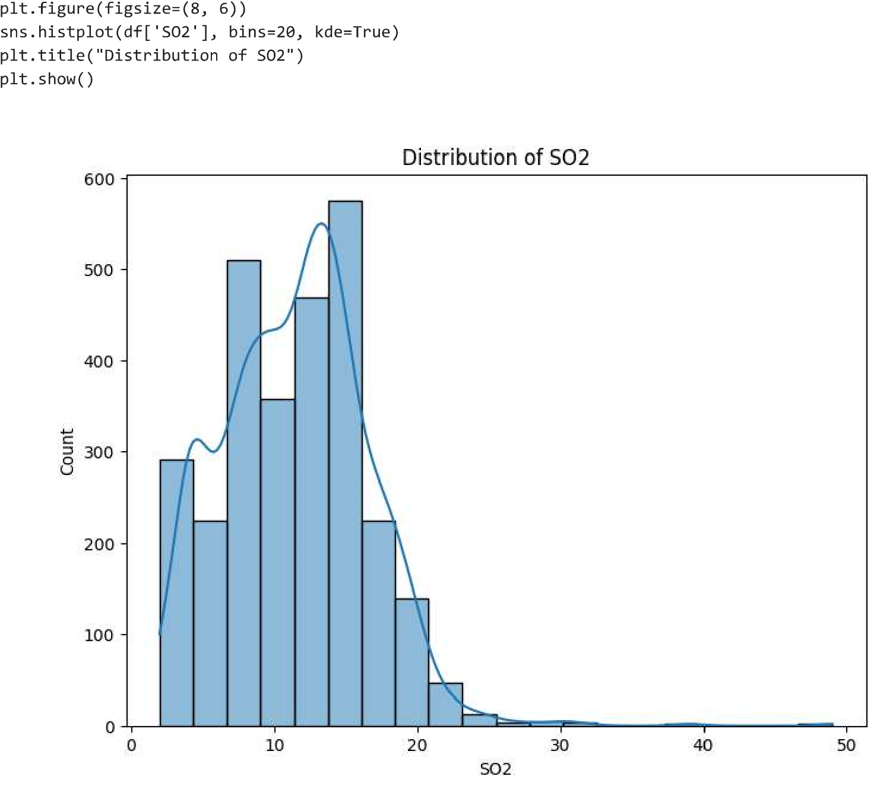

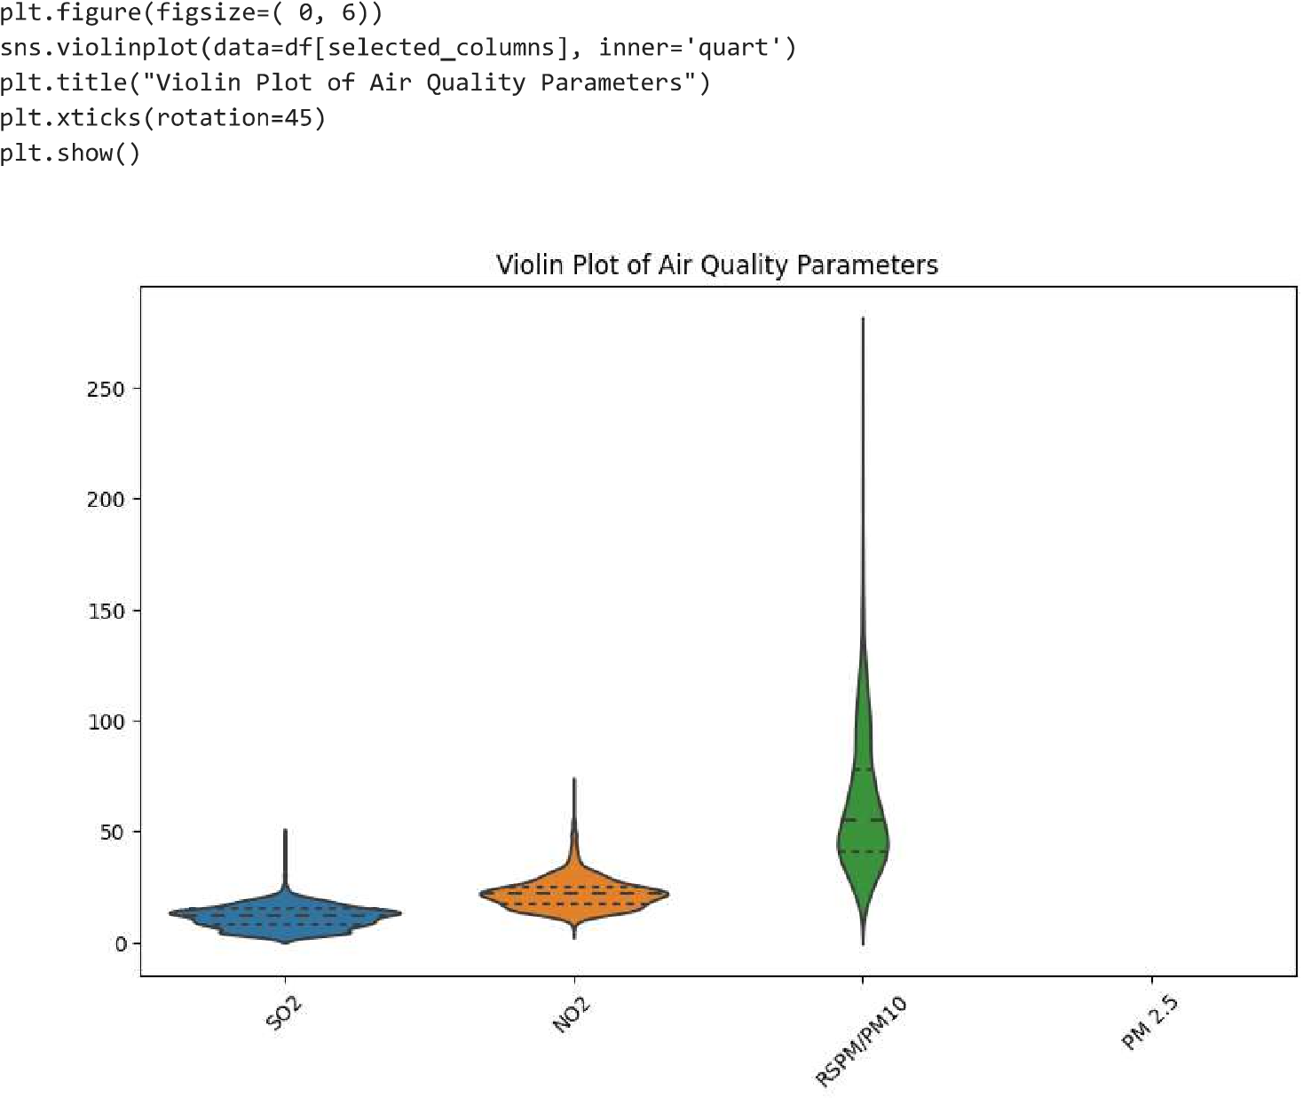

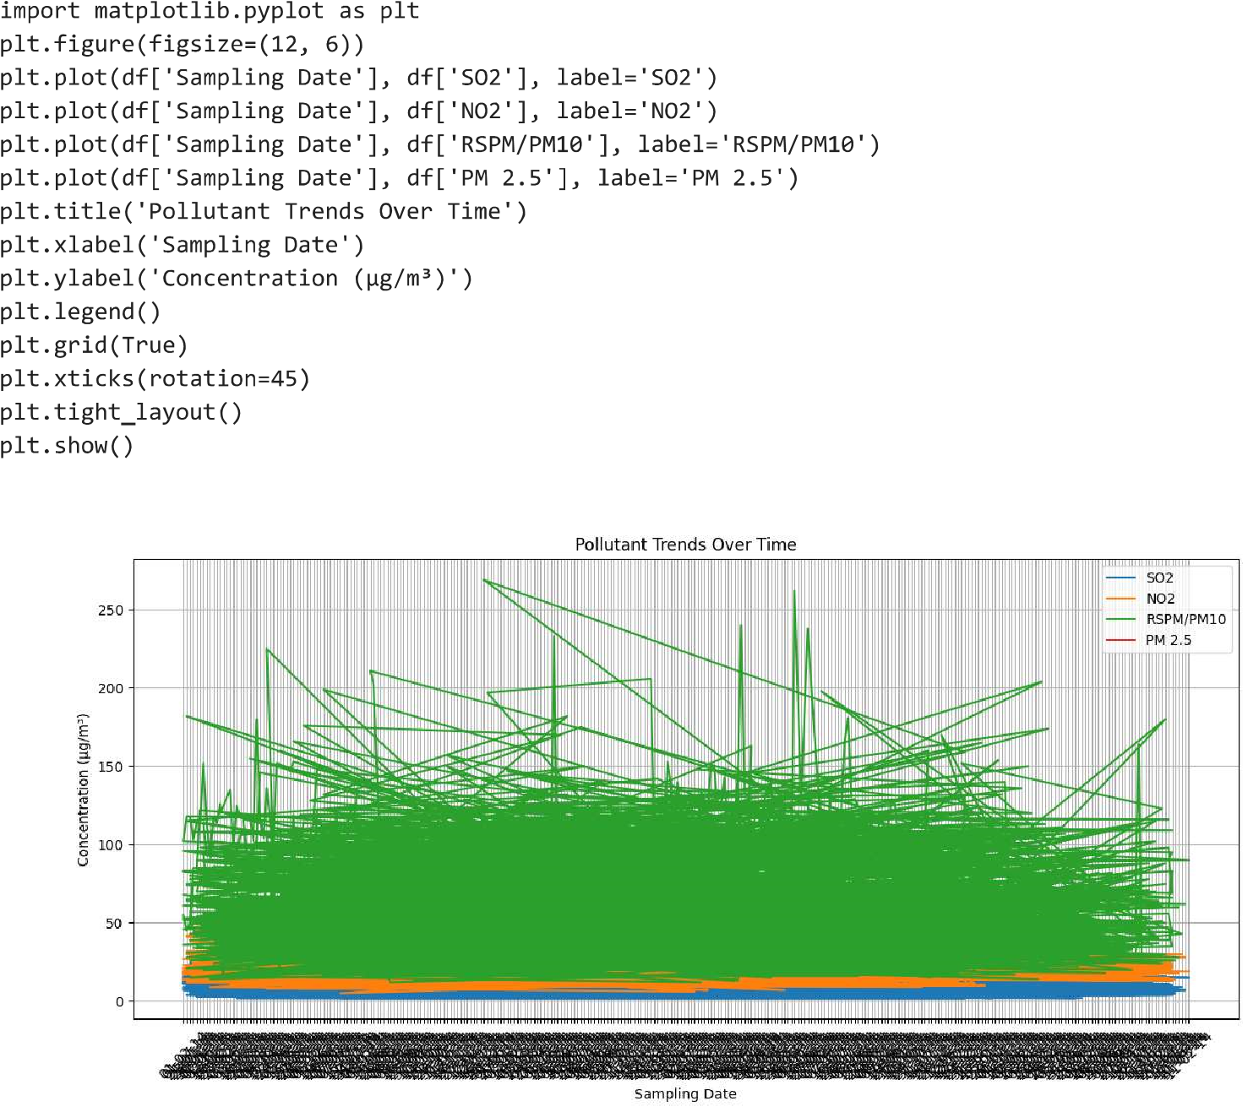

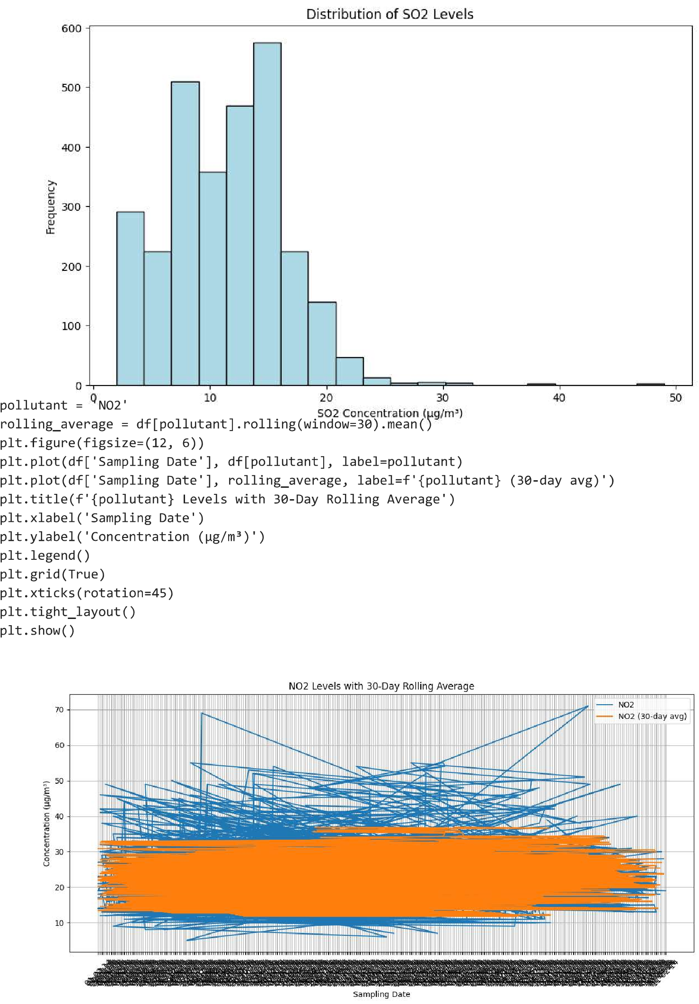

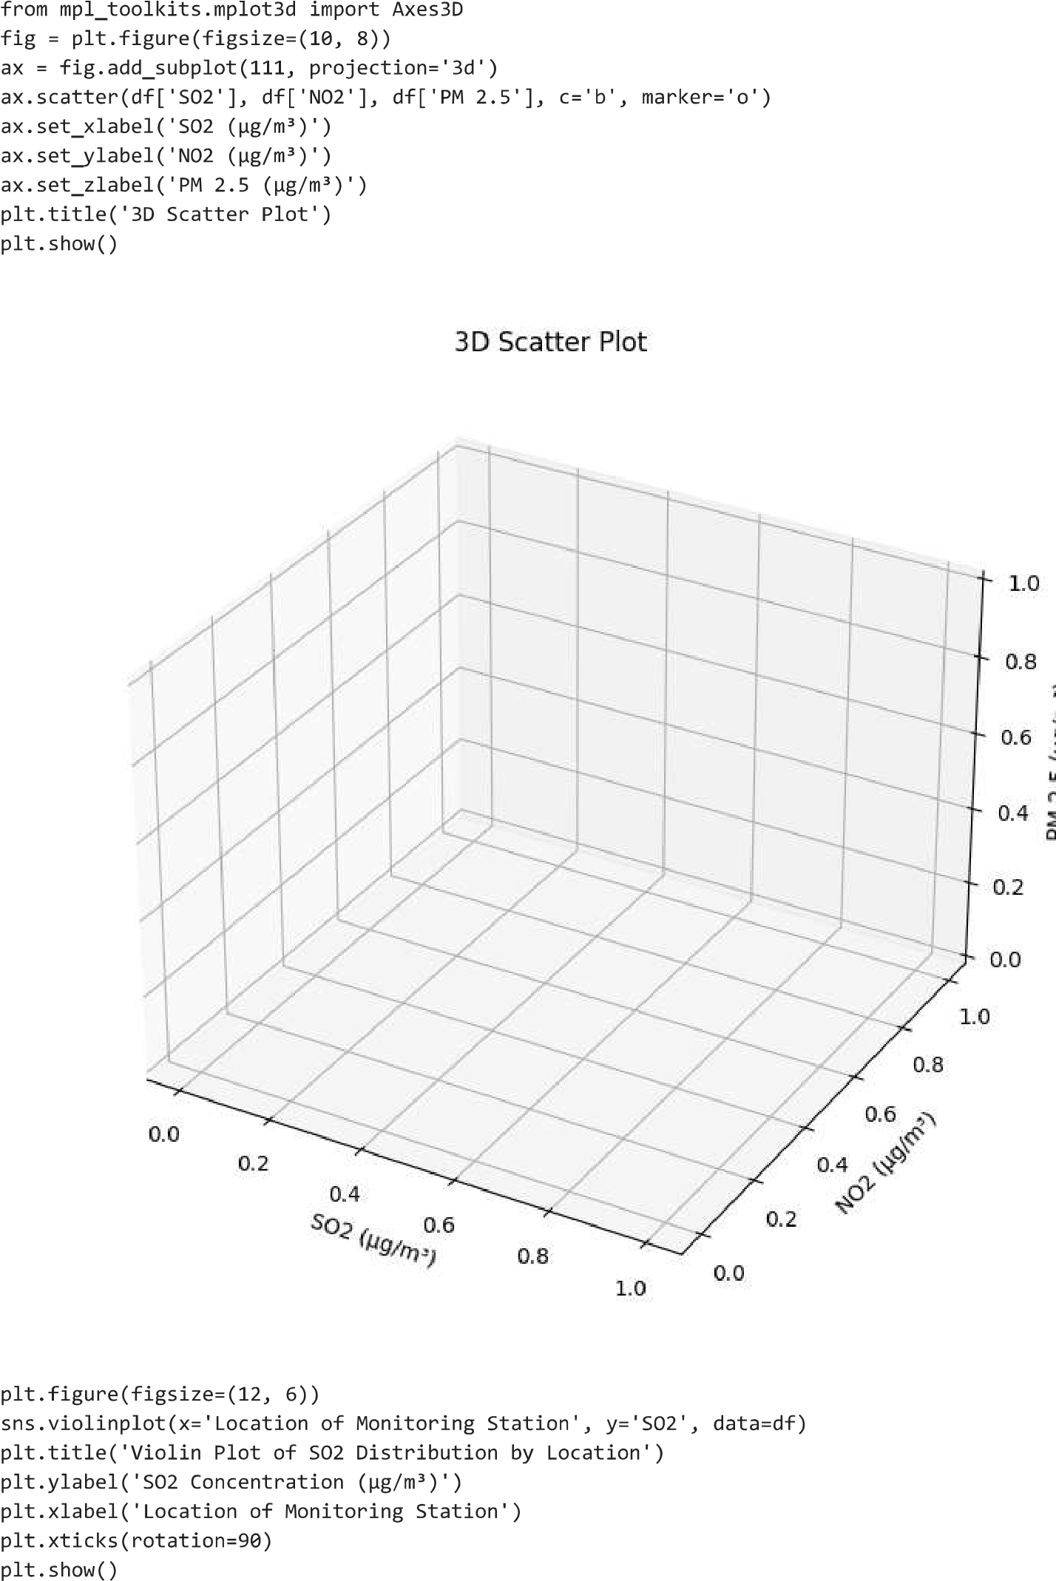

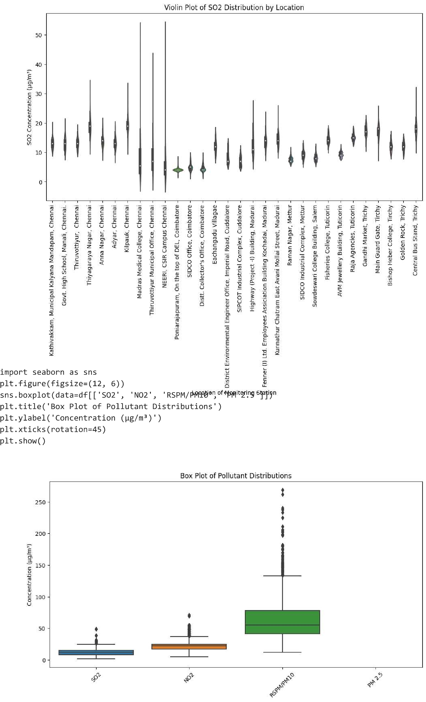

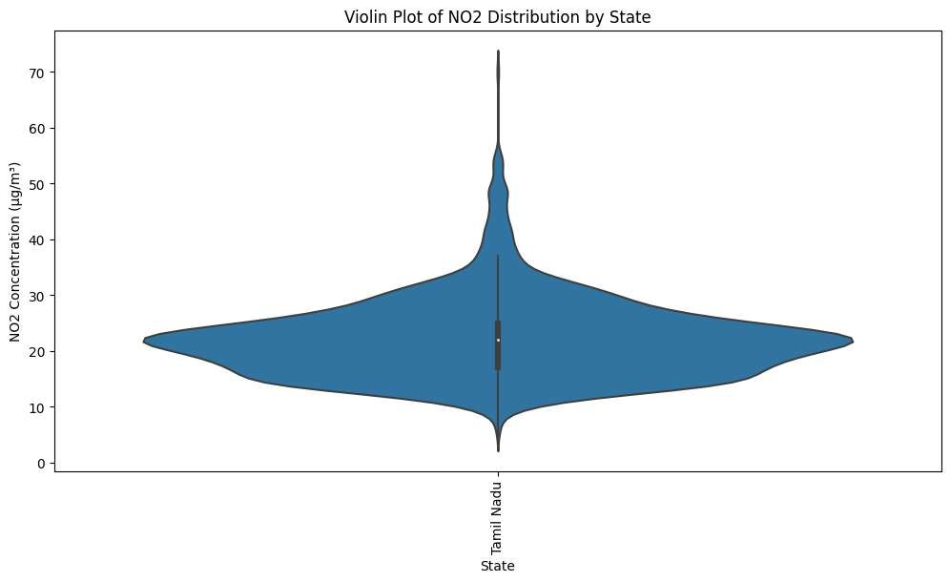

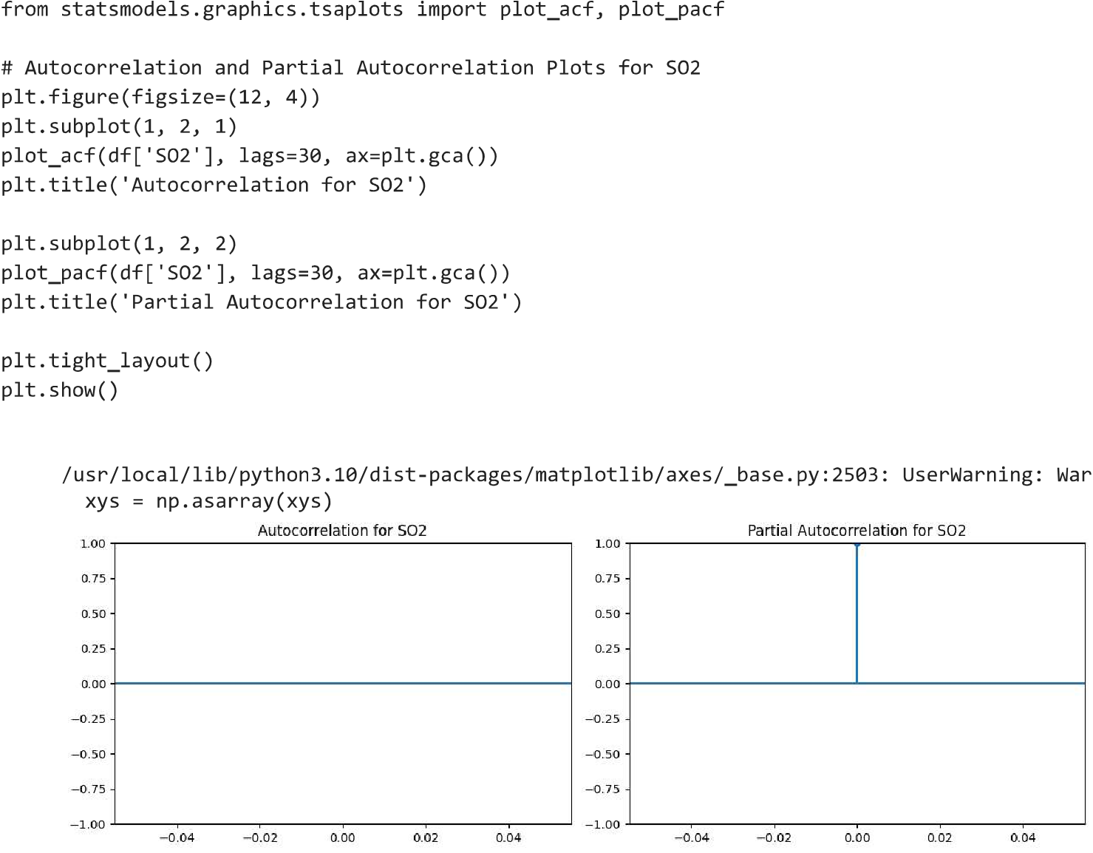

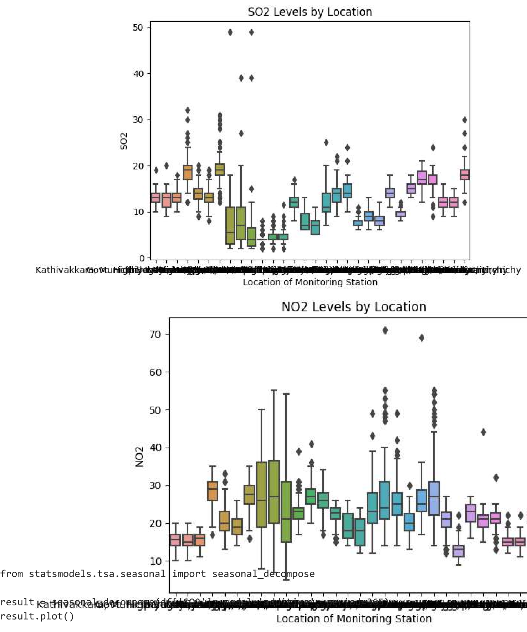

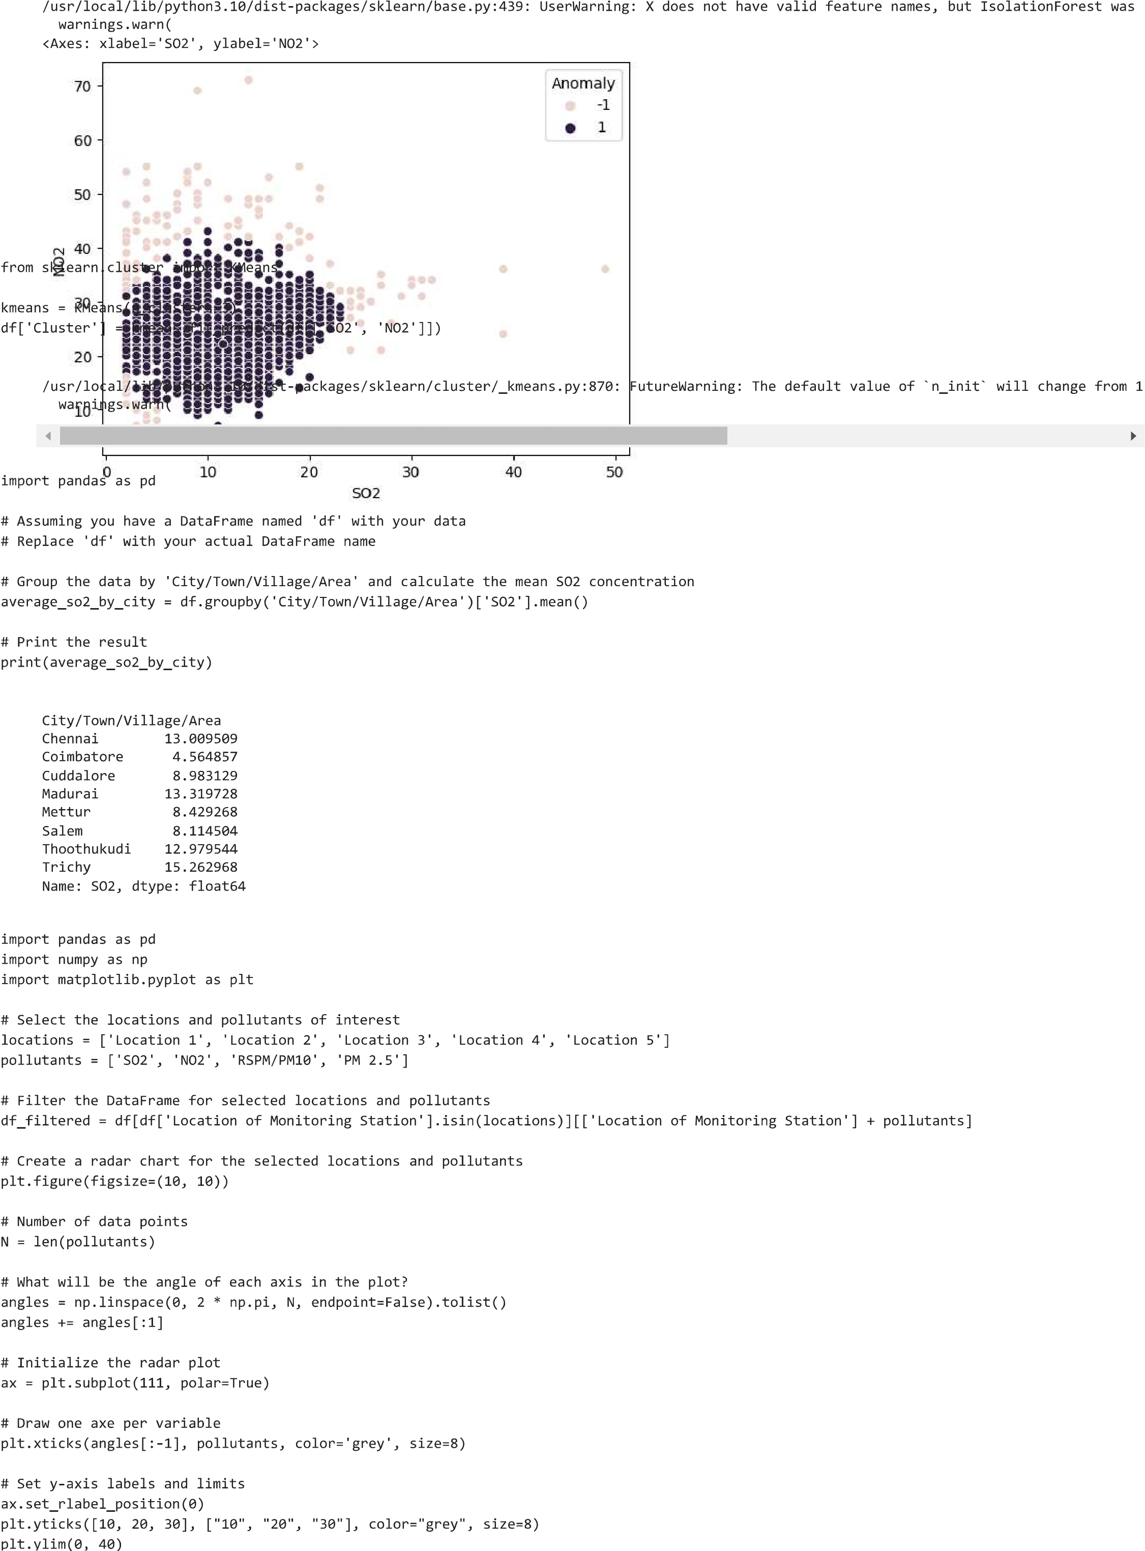

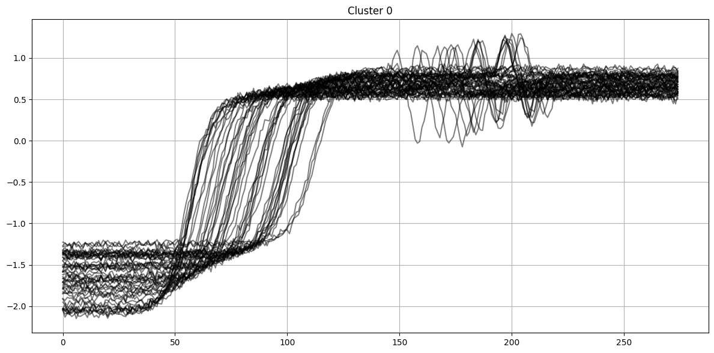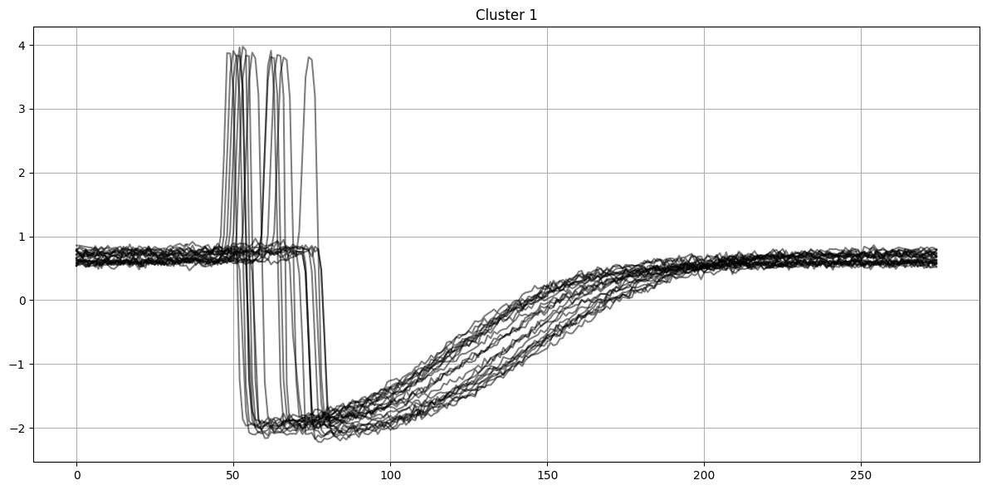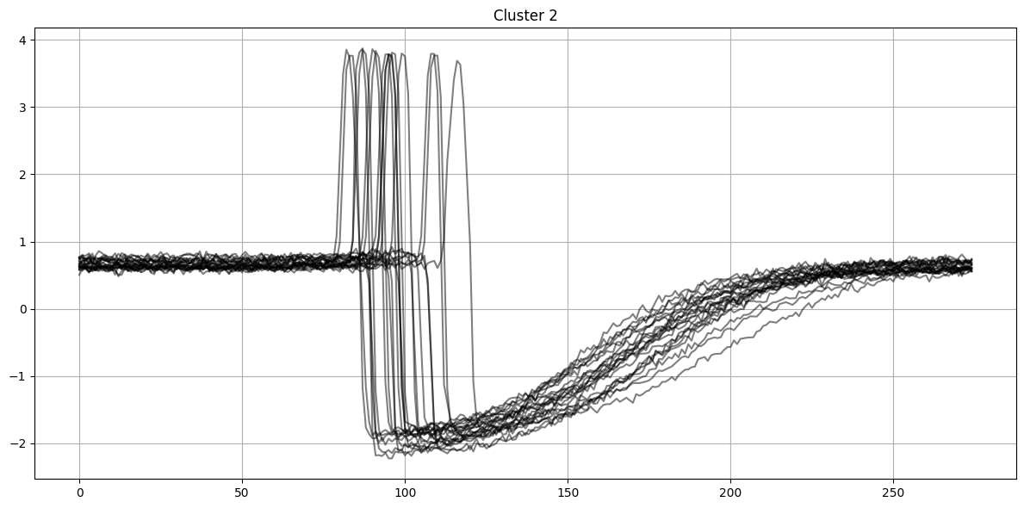

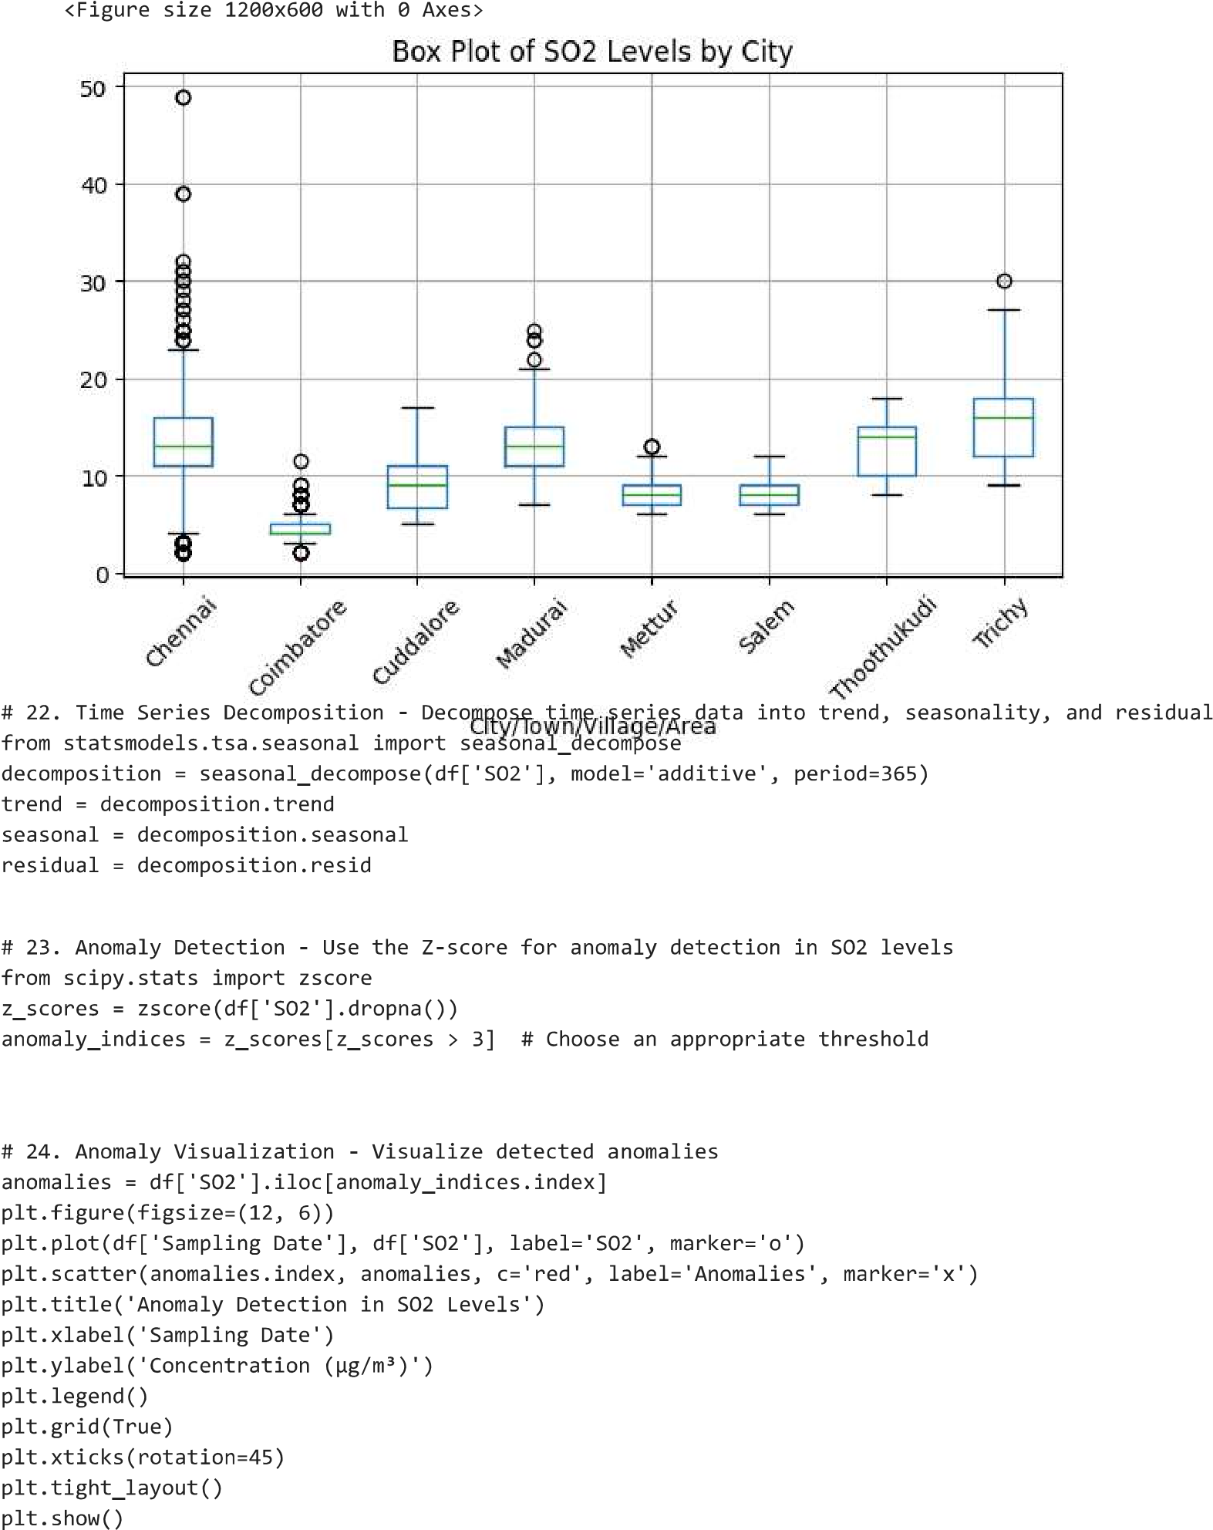





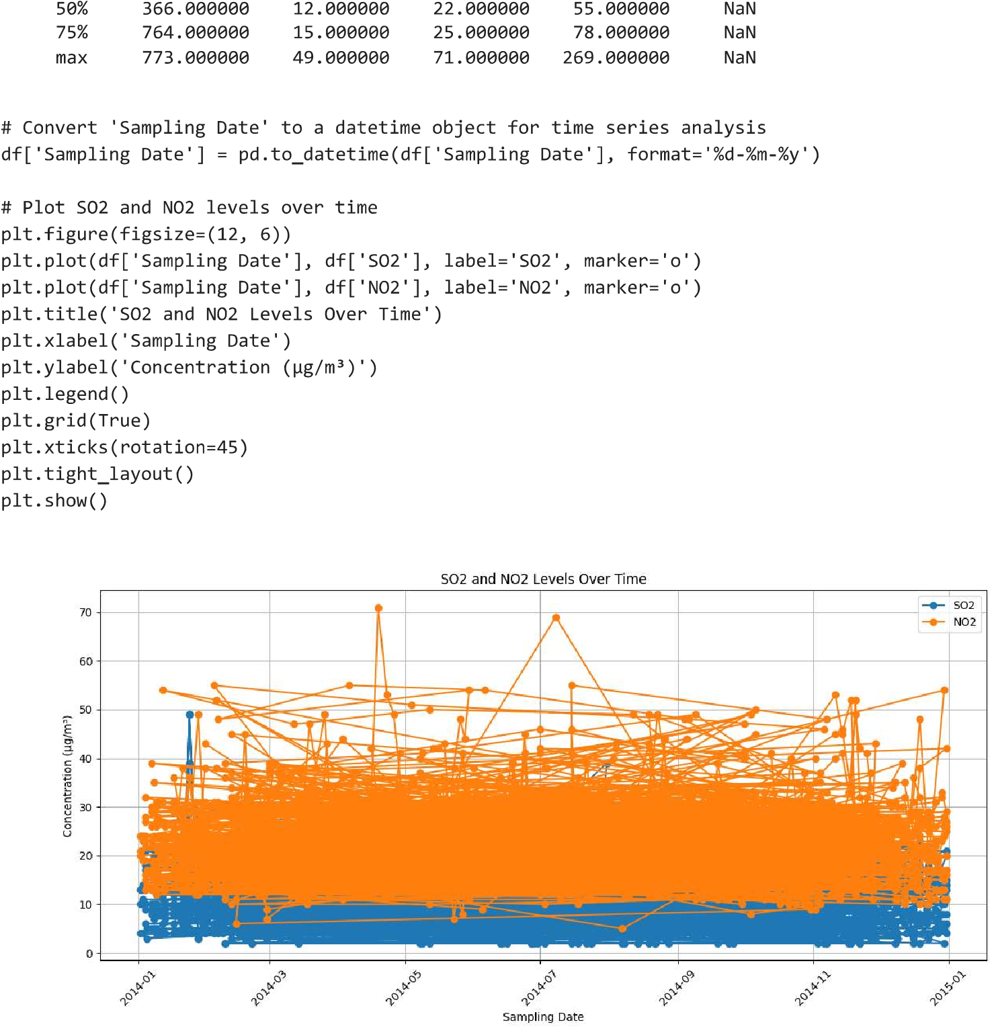

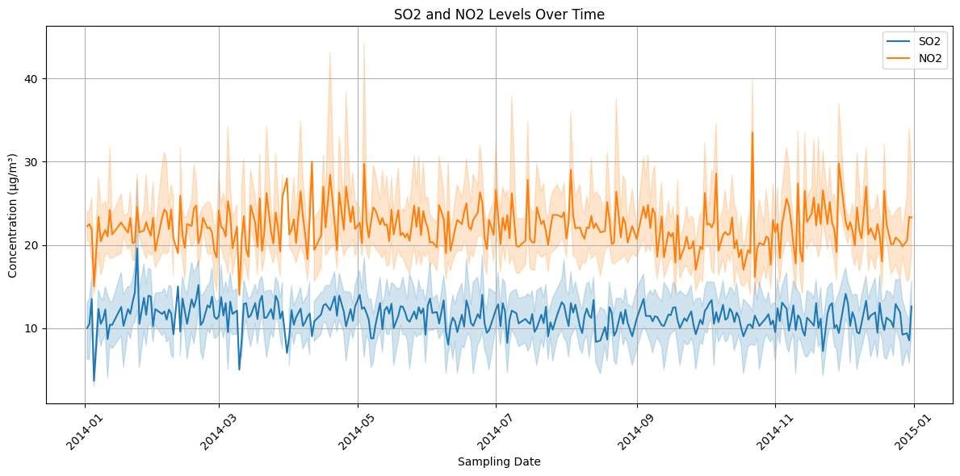

**Conclusion:**

*Our advanced data visualization techniques have breathed life into our analysis, unveiling insights that reverberate across domains. Our journey has revealed:*

***Temporal Patterns:*** *We've uncovered temporal patterns that span seasons, informing the development of policies and interventions that adapt to seasonal air quality fluctuations.*

***Spatial Realities:*** *Through geospatial heatmaps, we've exposed regional disparities in air quality, guiding targeted interventions in areas facing persistent air quality challenges.*

***Interactions Between Variables:*** *Our 3D visualizations have illuminated the complex relationships between air pollutants, weather conditions, and geographic factors, shedding light on the interplay of these variables.*

***Predictive Power:*** *Our predictive models offer a glimpse into the future of air quality management, empowering proactive measures and early interventions.*

*These insights extend their influence to environmental policy, public health initiatives, and urban planning, culminating in a holistic approach to managing air quality.*

*Our project paves the way for a cleaner and healthier environment. As we conclude, we present our vision for the future. Potential next steps include:*

*Enhancements in Predictive Models: Further development of predictive models to refine AQI forecasting.*

*Real-time Monitoring: Integration of real-time data for up-to-the-minute air quality assessments.*

*Community Engagement: Initiating community engagement initiatives to raise awareness and encourage public participation in improving air quality.*

*We are committed to sharing our insights, contributing to knowledge sharing and community well-being, and continuing our journey toward a more sustainable future.*

*Our project paves the way for a cleaner and healthier environment. As we conclude, we present our vision for the future. Potential next steps include:*

*Enhancements in Predictive Models: Further development of predictive models to refine AQI forecasting.*

*Real-time Monitoring: Integration of real-time data for up-to-the-minute air quality assessments.*

*Community Engagement: Initiating community engagement initiatives to raise awareness and encourage public participation in improving air quality.*

*We are committed to sharing our insights, contributing to knowledge sharing and community well-being, and continuing our journey toward a more sustainable future.*